RESUME Of -

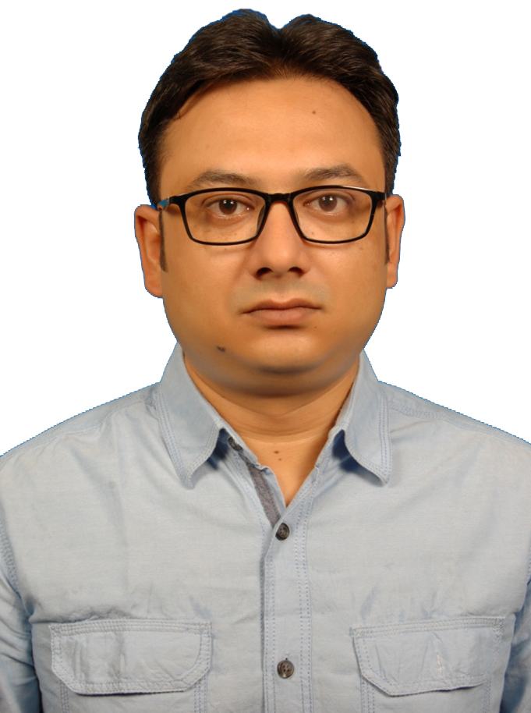
Contact Details Md. Rokibul Islam

C/O Ad. Md. Rofiqul Islam

Kadirgonj, (East side of Women’s collage Rajshahi)

House No- E-298, Post: Rajshahi-6000, Thana : Boalia

Rajshahi.

Contact Mobile # (880) 019123-11177, 01717-506506
E-Mail # mr_islam79@yahoo.com

OBJECTIVE:
To work is an environment where there is an opportunity of self-assessment and self-improvement in both individual and group based work that will ultimately lead to the further development of the common people.

Career Review:
Regional Sales Manager “raj IT Solutions Ltd.” “Software Development Company”1st Jan 2018 to Continue
Regional Manager “Dutch-Bangla Bank Limited.”ROCKET” 19 Sep 2016 to 30 Nov 2016
Zonal Sales Manager “Banglalink Digital Communications Ltd.” 2nd May 2006 to 18 Sep 2016
GPDC Officer “Grameenphone Ltd. 12th July 2005 to 30 April 2006
SEA Freight Executive “ACE Bangladesh Ltd 1st April 1999 to 30th April 2005

PROFESSIONAL EXPERIENCES:

“raj IT Solutions Ltd.” “Software Development Company” (Regional Sales manager)” 1st Jan 2018 to Continue
raj IT Solutions Ltd
Vodra Residential Area
House # 216, Road # 02,
Rajshahi,
Tel : +88-01676667555, 01709988542
www.rajit.net

Job Responsibility:
- Trained the Sales team
- Monitoring the regional Sales target
- Make quotation for attend the varieties tender regarding IT goods, Hardware & software
- Collect information about new tender opening by the relationship with corporate people.
- Always monitoring the competitor activities
- Update the product price ups & down from our vendor like Cell Phone, Smart, Pixel, Computer. Source, Global Brand etc.
- Attend all of IT fairs for demonstrate our new product
- Maintain relation with ICT of bangladesh
- Coordinate with Networking team, Programmer team & hardware Installation team

Working Area: Rajshahi Division

“Dutch-Bangla Bank Limited.”ROCKET” (Regional Manager)” 19 Sep 2016 to 30 Nov 2016
Financial Inclusion Division.
Rupayan Golden Age (3rd Floor)
House # 99, Road # 37,
Gulshan Avenue,
Dhaka 1212, Bangladesh.
Tel : +88-02-9882917, 9880391,98877923
Fax : +88-02-9883490
www.dutchbanglabank.com.

Job Responsibility:
- Managing the Sales team ( area manager, sales manager)
- Visiting distribution house & area.
- Make plans for proper distribution & Sales.
- Create the new idea for increasing sales volume.
- Monitoring the regional Sales team
- Monitoring the trade merchandising team.
- Make the Trade awareness & earn trade loyalty.
- Manage the very good relation with team & channel partners. Motivate our sales team and trade marketing also for increases our team speed.

Working Area: Rangpur, Kurigram, Lalmonirhat & Gaibandha

“Banglalink Digital Communications LTD.” (Zonal Sales Manager)” 2nd May 2006 to 18 Sep 2016
VimpelCom
Banglalink Digital Communications Ltd.
Tigers’ Den, House 4 (SWH)
Bir Uttam Mir Shawkat Sharak
Gulshan 1, Dhaka 1212
Bangladesh.
www.banglalink.com.bd

Job Responsibility:
- Managing the distributor and Business Management.
- Visiting distribution house & area.
- Make plans for proper distribution & Sales.
- Create the new idea for increasing sales volume.
- Coordinating the regional Sales team & collating Market Intelligence report
- Collecting information regarding others comparative Business for making strategic plans..
- Creating new idea for trade merchandising issue.
- Make the Trade awareness & earn trade loyalty.
- Manage the very good relation with team & channel partners. Motivate our sales team and trade marketing also for increases our team speed. like TMO (Trade merchandising Officer)

Establish a new distribution channel through Banglalink which is the best distribution channel in Telco Market and Make a good Business relation with local admin & social influential people.

Working Area: Rangpur, Gaibandha, Lalmonirhat, Rajshahi, Chapainowabganj, Natore, Pabna, Noagaon, & Joypurhat

“Grameenphone Ltd. (GPDC Officer)” 12th July 2005 to 30 April 2006
Grameen Phone Ltd.
Celebration Point,
Gulshan- 02
Dhaka – 1212, Bangladesh
(www.grameenphone.com)

Job Responsibility:

- Transmission of SIM Data through specially designed Software, Managing the Channel Partners and Business Management.
- Visiting Point of Sale.
- Loading / Stock Lifting plans as per the principal’s instruction. Develop new idea for increasing sales volume.
- Complete Reporting and through the Coordinator including Sales & Market Intelligence.
- Sales related documentation & Collecting information regarding others comparative Business.
- Coordinating with all sales related work.

Working Area: Dinajpur, Thakurgaon, Nilphamari & Panchagarh

“ACE Bangladesh Ltd (SEA Freight Executive)” 1st April 1999 to 30th April 2005
International Freight Forwarding Company
(Agent of Canadian Retail Sellers Association)
Land Mark Building,
Gulshan- 02
Gulshan-2. Dhaka-1212
Dhaka – 1212, Bangladesh
Contact Mobile # 9883915, 9895159, 9896435 Fax : 8819307
(www.acebangladesh.com)

Job Responsibility:

- Scope of Work includes Direct communication with the all the foreign principal’s. Including “Canadian Retail Sellers Association (CRSA).
- Transmission of PO Data through a specially designed EDI Software, Managing Ship windows on P.O’s, and P.O Management. Vendor Follow-ups.
- Loading / stuffing plans as per the principal’s or consignee’s SOP’s. Selecting the appropriate equipment for loading and arranging for stuffing.
- Complete Documentation including Booking procedures, issuance of Dummy copies, H B/L’s and FCR’s,
- Liner B/L’s and other shipping line related documentation. Coordinating with Port Operations in Chittagong.

Working Area: Dhaka & Chittagong

EDUCATIONAL QUALIFICATION:
2002– Session
MBA, (Major in Marketing)
Asian University of Bangladesh.
CGPA- 3.1
1997-99 – Session
National University – Bangladesh.
B.com. in Rajshahi Collage.
2nd Class.
1996 – Session
Rajshahi Govt. Collage Rajshahi.
H.S.C.
2nd Division
1994– Session
Rajshahi Collegiate School, Rajshahi.
S.S.C
1st Division
TRAINING / WORKSHOP:
- “Sales Leadership” (June 22 & 23’09) Institute Pengurusan Malaysia, Trainer mon Soh, a Doctorate of Business Administration
- “Trade Marketing & Distribution Excellence” (April 12 & 13’2008) BRACK Center, Rajendropur Dhaka, Trainer Mr. Ishtiaq Ahmed.
- “Effective Communication” (April 23 & 24’2009) Holistic Training Solutions, Trainer Lan Stern.
- “Planning & Organizing Workshop” (May 15 & 16’ 2010) Holistic Training Solutions, Trainer Lan Stern.
- “Sales Strategy & Planning” (September 24 & 25’ 2011) Holistic Training Solutions, Trainer Lan Stern.
- “Interpersonal Leadership Skill Development Program” (October 22 ,23 & 24’ 2015) Enroute Center for Development, Trainer Syed Taher Ahmed
RELEVANT LITERACY:
- Ensure the development and implementation of appropriate Administrative & HR polices.
- Working independently to maintain the company protocols
- Report to and communicate with Directors on Budget, Procurements, Crisis Management, and Capacity Planning etc. All Communication is on email or through conference call.
STRENGTH AND ACCOMPLISHMENT:
- Award get for best zonal sales manager of Rajshahi Region of Excellent Performance 2014
- High standard of ethical conduct, including an appreciation of and ability to abide by the Code of Conduct of any organization.
- Able to work independently, as well as being a strong team motivator and participant.
- Strong academic background, Steep learning curve and strong analytical ability.
- Worked extensively with the high-tech product.
- Continually focus on short-term and long-term goals and objectives of the department.
COMPUTER LITERACY:
- Operating System – Windows, Windows XP.
- Application - MS Word, MS PowerPoint, MS Excel, Adobe PhotoShop, etc.
- Working Knowledge on E-Mail & Internet
- Working knowledge on Computer Hardware
LANGUAGES LITERACY:
- English (Fluent in Speaking, reading &writing)
- Bengali (Fluent in Speaking, reading & writing)
COMUNITY ACTIVITIES:
- Involved with social activities
- And worked on various training & voluntary programs.
COMUNITY ACTIVITIES:
- Reading Books, Computer Magazine, etc.
- Novel and poetry.
- Playing Cricket .
PERSONAL INFORMATION:

Fathers Name : Md. Rofiqul Islam.
Father’s Profession : Lawyer
Mother’s Name : Ms. Shabiha Begum
Date of Birth : 31st August, 1979.

Permanent Address : Kadirgong, (East side of Women’s collage Rajshahi)

House No- E-298, Fourth stored Building; 1st Floor.

Post: Rajshahi-6000, Thana : Boalia

Rajshahi.
Telephone No: (0721) 770992, 01712192444
Nationality : Bangladeshi by Birth.
Marital Status : Married
Religion : Islam
REFERRENCE:
Tanvir Ahmed  Head of Regional Sales  Banglalink Digital Communications Ltd  Rajshahi Sales & Care Center  Upashahar Rajshahi  E-mail - tahmed@banglalinkgsm.net  Cell No-01911310822 |  |  | Akhtar Zaman  Managing Director  raj IT Solutions Ltd  H:321, R:01, Padma Residential Area,  Rajshahi-6207  E-mail – akhtaruzzaman@gmail.com  E-mail – akhtaruzzaman@rajit.net  Cell No-+8801755575801; +880721760210

(Md. Rokibul Islam)

